
INFOTECT SOLUTIONS
Snort Intrusion Detection System (IDS) Project Report
Project Title: Implementation and Analysis of Snort IDS
Organization: Infotect Solutions
Prepared by: Nana Kwame Amporful
Date: 30th December 2025

Executive Summary
This project presents the implementation and evaluation of a Network Intrusion Detection System (NIDS) using Snort for Infotect Solutions. The objective of the project was to install and configure Snort, monitor live network traffic, generate alerts, and analyze suspicious activity through a controlled simulated attack. The project demonstrates how rule-based detection can provide timely and actionable security alerts, helping reduce detection time for common network threats.
The entire exercise was conducted in a controlled lab environment using virtual machines. Snort successfully detected abnormal traffic patterns and generated meaningful alerts, validating its effectiveness as a lightweight and reliable intrusion detection solution.

1. Introduction
Modern organizations rely heavily on networked systems, making continuous traffic monitoring essential for early threat detection. Intrusion Detection Systems (IDS) play a critical role in identifying malicious or abnormal network behavior before it escalates into a full compromise.
This project focuses on deploying Snort as a Network Intrusion Detection System (NIDS) for Infotect Solutions. The work covers installation, configuration, traffic monitoring, alert generation, simulated attack testing, and rule analysis. The goal is to gain practical, hands-on experience with IDS operations while understanding how Snort rules function in real-world security monitoring.

2. Project Objectives
The main objectives of this project are:
- To install and configure Snort IDS successfully
- To monitor network traffic in real time
- To generate and analyze alerts based on detected threats
- To simulate an attack and observe Snort’s response
- To understand the structure and functionality of Snort rules

3. Snort Installation & Setup
3.1 System Requirements
- Operating System: Linux (Ubuntu/Kali Linux)
- Network Interface Card (NIC)
- Internet connection for package installation
Screenshot of the virtual machine( Kali Linux )
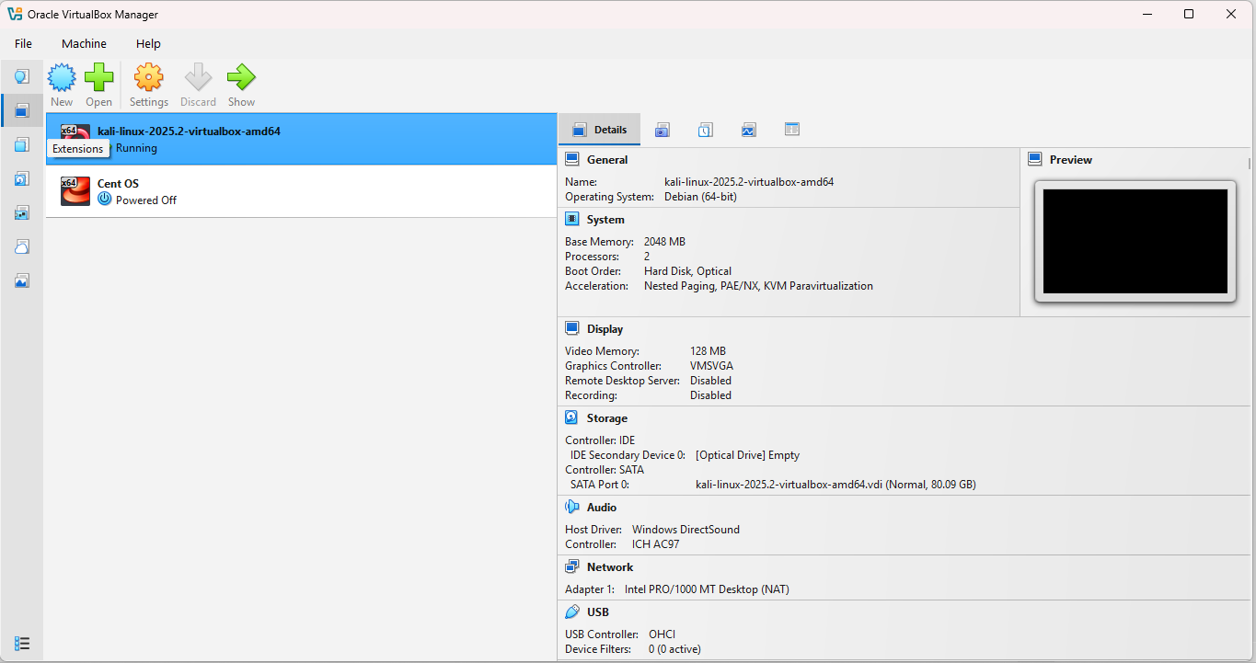
3.2 Installation Process
Snort was installed using the system package manager. The installation process included updating system repositories and installing Snort along with its dependencies.
Key steps included:
- Updating system packages
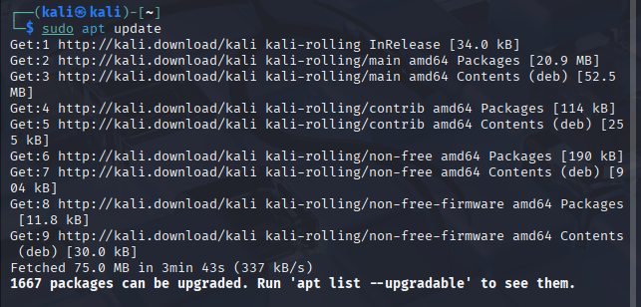
- Installing Snort
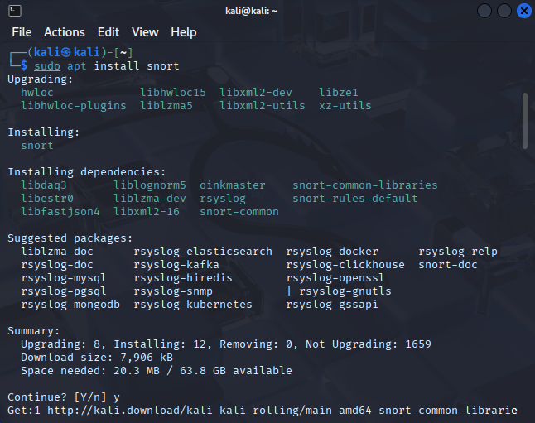
- Verifying Snort installation
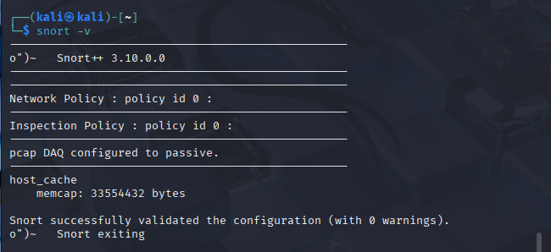
After installation, Snort was configured to run in IDS mode and bind to the active network interface.
3.3 Configuration
The Snort configuration file (snort.conf) was modified to:
- Define the HOME_NET variable
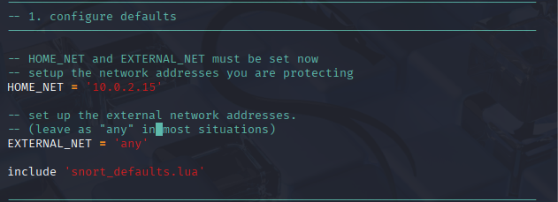
- Specify rule paths
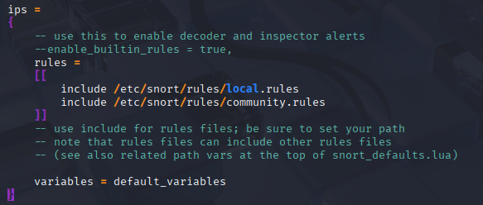
Proper configuration ensured that Snort could accurately monitor inbound and outbound traffic within the defined network scope.

4. Traffic Monitoring and Alert Generation
Snort was executed in network intrusion detection mode to monitor live traffic on the network interface. During this phase:
- Snort captured packets in real time
- Traffic was inspected against predefined rules
- Alerts were generated when suspicious patterns were detected
Snort logs and alert files were reviewed to confirm successful monitoring and alert generation.
📸 Screenshot: Snort running in IDS mode
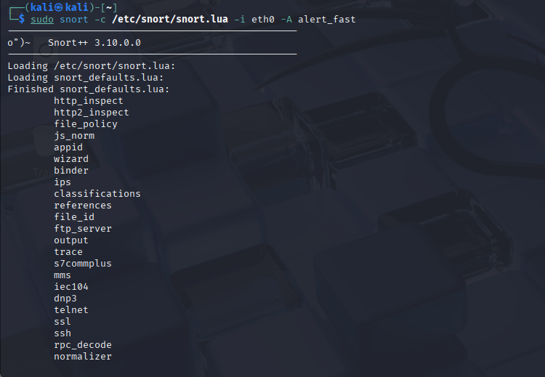
📸 Screenshot: Generated alerts in Snort alert log
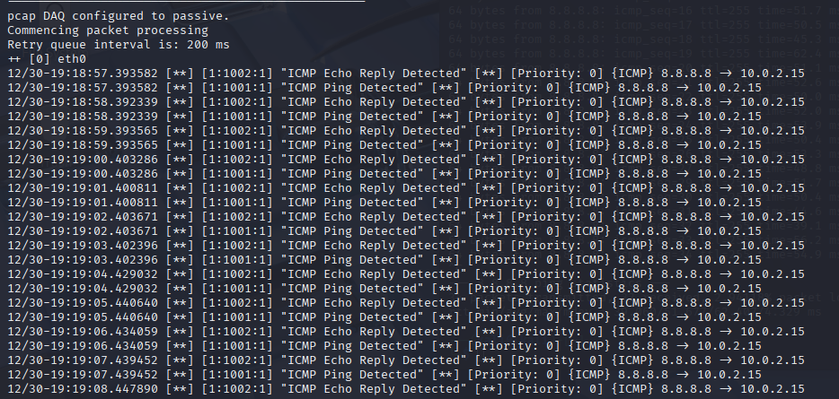

5. Simulated Attack and Alert Analysis
5.1 Simulated Attack
To test Snort’s detection capabilities, a simulated attack was carried out. The attack involved generating suspicious network traffic, such as:
- ICMP (Ping) flood

- Port scanning using Nmap
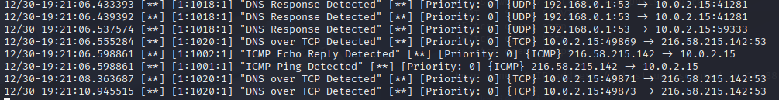
5.2 Detection and Alert Generation
Snort successfully detected the simulated attack traffic and generated alerts indicating:
- Source IP address
- Destination IP address
- Type of attack detected
- Timestamp of the event
5.3 Alert Analysis
The generated alerts were analyzed to understand:
- The nature of the attack
- Which rule was triggered
- The severity level of the alert
This analysis demonstrated Snort’s effectiveness in identifying and reporting malicious network activities.
📸 Screenshot: Snort alert triggered by simulated attack
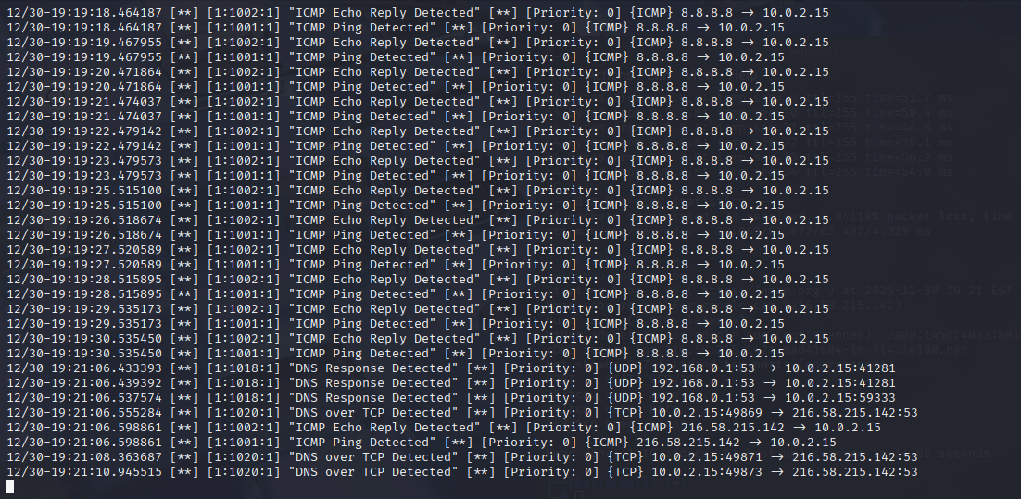

6. Understanding of Snort Rules
Snort rules form the core of its detection engine. Each rule consists of two main parts:
6.1 Rule Header
The rule header defines:
- Action (alert, log, pass)
- Protocol (TCP, UDP, ICMP)
- Source and destination IP addresses
- Source and destination ports
6.2 Rule Options
The rule options provide detailed information such as:
- Message to display when rule is triggered
- Content to match in packets
- Rule ID (SID)
- Revision number
Example Snort Rule:
alert icmp any any -> $HOME_NET any (msg:"ICMP Ping Detected"; sid:1000001; rev:1;)
This rule generates an alert whenever an ICMP ping is detected targeting the home network.
📸 Screenshot: Custom Snort rule configuration
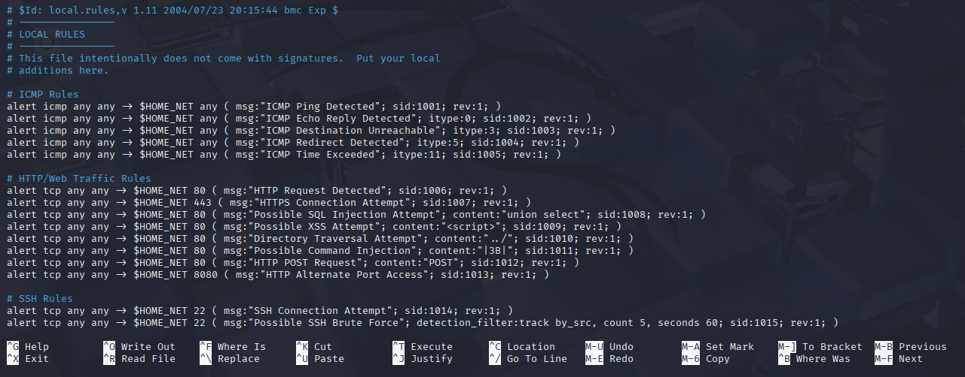

7. Conclusion
This project successfully demonstrated the installation, configuration, and use of Snort IDS for network security monitoring at Infotect Solutions. Through real-time traffic monitoring, alert generation, and simulated attacks, Snort proved to be an effective tool for detecting suspicious network activities.
The project also enhanced understanding of Snort rules and their role in intrusion detection. Snort remains a valuable and cost-effective solution for organizations seeking to strengthen their network security posture.

8. References
- Snort - Open-Source Network Intrusion Detection & Prevention System || Cisco Talos Intelligence Group - Comprehensive Threat Intelligence

- Snort 3 Rule Writing Guide - Snort 3 Rule Writing Guide

End of Report

